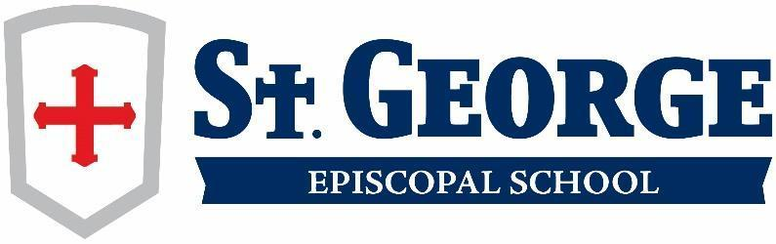

Lower School - 4th Grade Overview

Fourth grade is a year of increasing independence and responsibility as students continue to attend departmentalized classrooms with three teachers for their core curriculum. Students learn to organize and manage their time, materials, and assignments. The curriculum includes many opportunities for students to collaborate, discuss, and grow as learners.

# Reading: The fourth grade reading program components include comprehension, oral reading, and the study of figurative language. The curriculum focuses on a variety of texts and genres and often integrates with social studies and science curricula. The program utilizes classroom novels for teaching reading strategies necessary to become proficient readers. These strategies are then applied in small group literature circles and culminating activities that apply higher order thinking and presentation skills. The curriculum includes an independent reading journal that provides enrichment and motivation for outside reading.

# Spelling and Vocabulary: Spelling instruction includes learning letter combinations, word parts such as prefixes and suffixes, and frequently misspelled words. The *Words Their Way* curriculum incorporates print and digital resources allowing students to focus on areas in which they need support based on individual spelling inventories. Fourth grade also serves as an entry point for Greek and Latin roots. Students continue their study of synonyms, antonyms and word analogies through the *Shurley Method*. Fourth grade also provides consistent opportunities for students to expand their vocabulary through content area reading and writing.

# Grammar and Writing: In fourth grade, the language arts program has deep roots in grammar study and parts of speech through the use of the *Shurley English* curriculum. During the first semester, there is a review of basic conventions through spiral activities including rules of punctuation, capitalization, word usage, and sentence structure. Students are introduced to the *Six Traits of Writing* with special emphasis on authentic writing opportunities. All students work toward fluency through timed writings and journal activities. Writing is taught across the curriculum in all subject areas throughout the school year. Fourth graders publish a variety of authentic compositions in the form of expository and persuasive essays, narratives, creative pieces, and reflective writing. Cursive handwriting is used in all subjects at this level.

# Math: The fourth grade math curriculum is a high-intensity program that stresses problem solving, computation, and higher order thinking skills to develop competence and confidence in all areas of mathematics. Using the *Dimension Math* program, students move from concrete and pictorial representations to abstract algorithms, viewing the same concepts over time with increasing levels of abstraction. In addition to traditional math strategies, mental math skills and alternative problem solving methods are incorporated. Major objectives taught include: place value, fractions, computation, statistics, geometry, and measurement. The use of manipulatives, math games, daily math journals, and cooperative group activities meet a variety of learning styles.

**Science:** The fourth grade science curriculum offers a comprehensive and rigorous hands-on approach to learning by following the *Texas Essential Knowledge and Skills* (TEKS) as a foundation. Building a strong science foundation for students allows for genuine scientific extensions unique to St. George Episcopal School. We will use the learning platform, *EduSmart*. *EduSmart* provides one place for all science resources, is aligned to state standards with bite-sized instructional videos, lab simulations, interactives, and assessments. *EduSmart* brings science to life by using real-world examples relevant to your students' everyday experiences. It is designed to stimulate each student’s sense of wonder, desire to problem-solve, and think critically. Students regularly complete experiments and hands-on investigations in the science lab. Units include the study of matter, force, motion, energy, Earth and space, organisms and environments.

# Social Studies: Using the *Core Knowledge* curriculum, students begin the year with a review of geography and geographical terms. Other curricular units of study include world mountains, m[edieval](https://www.coreknowledge.org/free-resource/ckhg-unit-03-medieval-europe/) [Europe](https://www.coreknowledge.org/free-resource/ckhg-unit-03-medieval-europe/), dynasties of China, the American revolution, and the U.S. Constitution. During the second semester, fourth graders study Texas history as they focus on major historical events, important figures, and economic trends in the development of modern day Texas. In the culminating event of their economics and entrepreneurship unit, students join together to form and run businesses at the school-wide trade fair, Le Marché.

# Social and Emotional Development: The St. George social and emotional curriculum is based on the *Responsive Classroom* model, which takes a proactive approach that focuses on creating a loving and respectful classroom community where each child feels valued and known by his or her teachers and peers. Every day begins with a morning meeting where students are greeted by name and invited to share about their lives. During this time, teachers introduce a variety of social skills throughout the year including: identifying feelings of self and others, resolving conflict, showing kindness, listening and responding, regulating emotions, practicing empathy, being a good citizen, and standing up for what is right. These skills are then discussed and modeled frequently by children and teachers alike. This approach provides each student with the tools to grow his or her own emotional intelligence, while also creating an environment of connectivity and care.

# Co-Curricular Classes: Students attend the following co-curricular classes: art, music, library, science lab, STEAM, and technology once a week; Spanish twice a week; physical education three times a week, and recess daily. Students also attend a developmentally appropriate chapel daily.